구조 설계 (System Design)

ZIGBEE PROTOCOL STACK

컴퓨터네트워크 연구실
인제대학교
(초록) 본 문서에서는 … 에 대해 기술한다.

목 차

1 시스템 설계서 (System Design) 4
1.1 개요 (Introduction) 4
1.2 시스템 설계 개념 (Concepts for System Design) 4
1.2.1 용어의 정의 (Definition of Terminologies) 4
1.2.2 설계 개념 (Design Concept) 4
1.3 시스템 구조 설명 4
1.3.1 시스템 구성 (System Architecture) 4
1.3.2 전체적 기능 흐름 (Overall functional flow) 5
1.3.3 세부 기능 (1) Zigbee component 5
1.3.4 세부 기능 (2) 802.15.4 component 5
1.3.5 세부 기능 (3) OS-AL 5
1.4 구성 요소 설명 (Description of internal components) 6
1.5 시스템 특성 (System Characteristics) 6
1.6 부록 (Appendix, if any) 6

시스템 설계서 (System Design)

개요 (Introduction)
This document defines software system architecture of Zigbee protocol stack which will work on the Mega128 and C2420. Specification of the on board system is define in TBD

시스템 설계 개념 (Concepts for System Design)

용어의 정의 (Definition of Terminologies)

ZPS | Zigbee protocol stack
TBD | To be define

설계 개념 (Design Concept)
The software is designed by dividing into functional blocks. All methods to describe software functionality are accepted in this document.

시스템 구조 설명

시스템 구성 (System Architecture)

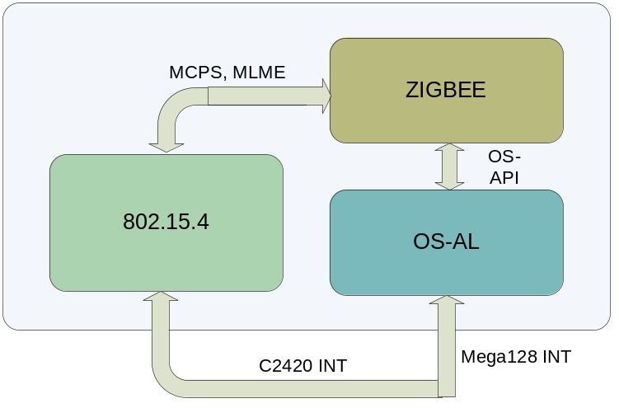
Figure 1: ZPS system architectures
The system is divided into three components:
- Zigbee: Software component that works on behalf of the zigbee protocol stack defined in the Zigbee standard.
- 802.15.4: Mac layer following the standard 802.15.4. This is an independent software component that will manage the INT from C2420 to provide the functions of MAC.
- OS-AL: Operating system Abstract Layer that will provide functionality of a reduced (or full) operating system.

전체적 기능 흐름 (Overall functional flow)
Zigbee component uses MCPS and MLME services from 802.15.4 to transmit and receive data frames. Scheduling and resource management of Zigbee stack and Zigbee application component will be supported by OS-AL.
INTs will be managed by 802.15.4 and OS-AL:
- C2420 related INT: will be managed by 802.15.4. They are int related to C2420 and timer assigned to support C2420.
- Mega128 INT: will be managed by OS-AL. They are all int except C2420 INT. They includes power INT, timer INT… and others external INT.

세부 기능 (1) Zigbee component
Implementation of Zigbee stack defined in the Zigbee standard

세부 기능 (2) 802.15.4 component
This component will provide services:
- MCPS and MLME services as defined in the 802.15.4 standard
- Independent scheduling to schedule for MAC services
- Independent memory management services for MAC services
- INT routine to handle C2420 related INT

세부 기능 (3) OS-AL
This component acts as a simple OS (or full OS) that will manage task and resource in Zigbee stack and Zigbee applications. OS-AL is needed to simplified the development phase for Zigbee and Zigbee applications. Necessary services must be provided by this component:
- Task scheduling
- Inter-process communication
- Memory management
To reduces the load for the micro processor. OS-AL must also have following characteristics:
- API is simple to used
- Without any unused functionality
- Size is as small as possible

구성 요소 설명 (Description of internal components)
NA

시스템 특성 (System Characteristics)
NA

부록 (Appendix, if any)
NA

